Where did students come from to study in your local area in 2001? Extracting student migration data and producing cartographic flow line summaries.

This practical will enable you to answer the research question above through enabling you to produce meaningful cartographic output from WICID interaction data.

Part 1 – Data Extraction from WICID

1.1 Log into WICID and click on Query Interface to start building your query.

1.2 Firstly, click on Geography > Select or edit origins to select the origin geography you wish to use.

1.3 For this task choose list selection and then select CIDS 1991/2001 common geography - '100 zones'

1.4 Confirm that you wish to use this geography and then click the add all areas button as we are going to examine the numbers of students migrating from all 100 zones to our zone of choice.

1.5 Now you will need to select a destination zone. Click select destinations > list selection and confirm that you wish to proceed using the same geography.

1.6 Now you may select any destination that interests you. Once you have selected your destination zone by ticking the box next to it, click add chosen areas to add the area to your destination selection. Once this is done you need to move on to select data.

1.7 At this point you may wish to click on the current query summary button to view the summary of your current query. You should see that 100 origins are selected along with the 1 destination you have chosen. If you click on the Query: Start button at the top of the page, you should now be able to see that you have a green light next to Geography. Having selected origin and destination geographies, you are now in a position to select your data.

1.8 When selecting data in this exercise we will select by dataset and table, and use the 2001 SMS level 1 dataset > Table 5 – Economic Activity by Sex

1.9 In this table you should select the total economically active full-time students as well as the total economically inactive students (cells 22 and 31). Once ticked, click the add selected cells button.

1.10 At this point we are going to derive a new variable from the two just selected. Click the derive new variables button, select both items and continue. Give your new aggregate variable the name ‘total students’ and remove the old variables from the list of selected items before clicking continue.

1.11 You should now return to the query builder (Query: Start at the top of the page), where a green light should be present next to data. If you want to you may view your current query summary, but when satisfied you should click run query to extract your data and then continue to output pages selecting tabular output.

1.12 On the tabular output plan page you should select origin – destination pair list as the output layout and comma separated values as the output format. Click on preview output and download file to download your data selection. Call your file ‘StudentMigrations.csv’ before clicking the button to download the file to a specified directory of your choice.

1.13 Once downloaded, open the file and delete the first 4 rows replacing the headings in the first row above the data with the words ‘origin’, ‘destination’ and ‘total students’. Scroll to the bottom of your file and delete the notes and source information as it is not required. Save the file as an excel (.xls) file and close it.

Part 2 – Mapping the information using MapInfo

2.1 Start MapInfo and Open the file ‘UK100Zones.TAB’ attached with this practical.
Also open your ‘StudentMigrations.xls’ file and save a copy in MapInfo as ‘StudentMigrations.TAB’ (in newer versions of MapInfo the .TAB file is created automatically when you open the excel file, so you may not have to save a copy).

Obtaining Zone centroid coordinates.

2.2 For this mapping exercise you will need to find the centroid of each of the 100 Zones. To do this, you will need to select Tools > Coordinate extractor > extract coordinates (if the coordinate extractor is not already listed, you will need to go into the tool manager and tick the box next to coordinate extractor to add it to your list).

2.3 You will need to extract the coordinates from the UK100Zone table. Check that the projection is set to ‘British National Grid’ and you should click the create new columns to hold coordinates… button and call the new table columns ‘OriginX’ and ‘OriginY’. Once you click OK, you should be able to view the table with the X and Y coordinates created for each of the 100 Zones.

Adding the attribute data to the boundary data.

2.4 To combine your attribute and boundary data into one mappable table, you will need to use the SQL select function in MapInfo. Go to Query > SQL Select. When the module opens you should select all columns (*) from the tables StudentMigrations and UK100Zones where condition column StudentMigrations.origin = column UK100Zones.Cname. When you click OK your two tables should now be joined together into a single table.

2.5 Save the query as a new table called ‘StudentMigrationFlows.TAB’ and then close all tables.

Creating destination zone coordinates.

2.6 Open your new StudentMigrationFlows.TAB file. Also open the UK100Zones file. To begin with, you will need to add two new columns to your StudentMigrationFlows table. To do this, go to Table > Maintenance > Table Structure and select the StudentMigrationFlows table. Add two fields named DestX and DestY of the type ‘Float.’ Click OK and then re-open the table. You will see that two new empty columns have been added to the end of your table.

2.7 To create the destination coordinates in these columns, do the following: Select Table > Update column. Firstly, update your new DestX column, and get the value from your UK100Zones table. You will need to join your tables where destination in your StudentMigrationFlows table matches Cname in the UK100Zones table. In this case, you are copying the value of OriginX from where your destination appears in the origin column, so select calculate the value of OriginX, before clicking OK. You should now see your DestX column updated with the X coordinates from your selected destination. To fill your DestY column with coordinates, follow the previous step substituting OriginX for OriginY where appropriate. Once done, save your table.

Mapping the migration flows

2.8 Your StudentMigrationFlows table should now contain the UK100Zones boundaries, the data you wish to map and the coordinates of the zone centroids for both the origins and destination you want to map. You now will need to make a copy of StudentMigrationFlows, and call it something like ‘StudentMigrationFlows1’. To do this, use the Save copy as… option in the file menu. You are doing this as it is this version of the table you are going to make the flow lines from.

2.9 Close all tables and open your new StudentMigrationFlows1 table. Go to the options menu and select Show MapBasic Window. Once the MapBasic window has opened, to create the flow lines, type the following:

Update StudentMigrationFlows1 set obj = CreateLine(OriginX, OriginY, DestX, DestY)

2.10 Once you hit the return button, you should see lines created from the centroids of each of the 100Zones origins to the centroid of your chosen destination. You may find that the map window remains blank. If this occurs, it is because the Map Window settings are incorrect. You can solve this problem by going to the Options menu > Preferences > Map Window and setting both the Table projection and Session Projection to British Coordinate Systems and British National Grid. Then run your MapBasic command again and the flows should appear in the Map Window.

2.11 Currently you will only see the lines displayed on your map. To display the UK100Zones boundaries with your map, you should re-open either the StudentMigrationFlows table or the UK100Zones table. Doing this should automatically add the zone boundaries to your map with flows lines.

2.12 This next stage is to produce a thematic map so that the flow lines are displayed of differing thickness depending on the flow size. Go to the Map menu and select Create thematic map. You should choose Line Ranges, Varying Width style. In step 2, select StudentMigrationFlows1 and choose a variable you wish to see mapped – in this case your only choice is likely to be ‘total students’. Click Next to go to step 3 where you can customise your map (for example you may wish to alter the colour of some of the lines to add additional clarity to your map, or change the legend). Click OK and a flow map will appear which allows easy interpretation of from where students are migrating from, to your chosen area.

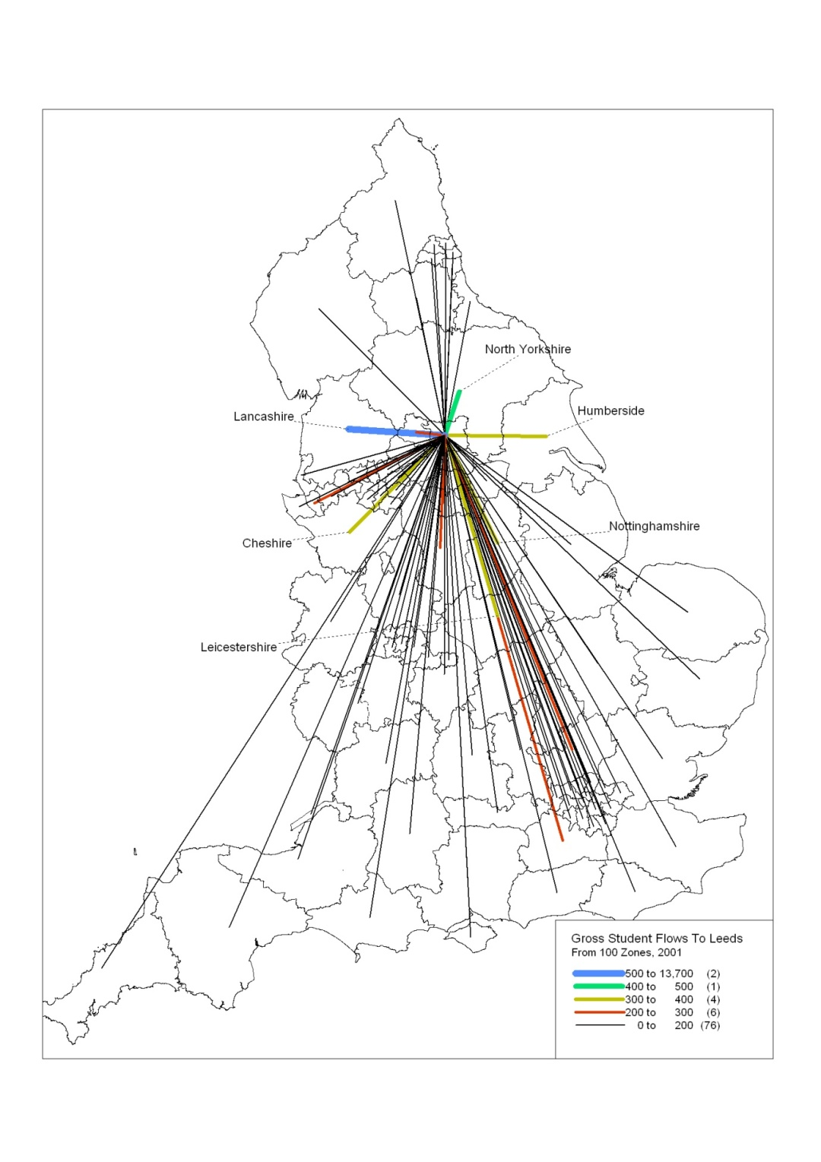
Figure 1 – An example flow map showing student flows to Leeds from 100 Zones areas in England.

